

**Ecommerce report on GAME**



To: Kevin Edwards

From: Callum Pope

Date: 28/09/16

Table of Contents

Introduction 3

Business background 4

Analysis of current ecommerce system 6

Global impact of ecommerce on society 7

Conclusion 8

Bibliography 9

Appendices 10

# Introduction

This report will cover the ecommerce offering of the UK business GAME evaluating its effectiveness, how it can be improved and whether the ecommerce site is secure. A judgement will then be made on the overall security of the site and how (if necessary) it can be improved.

# Business background

GAME is UK based and UK founded company by the rhino group in 2002 with stores located mainly in Spain and the UK, specialising in the sale and distribution of physical and digital games, consoles and gaming merchandise including toys, clothing, console accessories etc. It is a private limited company, meaning that there is no government involvement and makes use of limited liability. This means that the company and its shareholders are responsible for only the share value of any debts. The mission statement of the business is “to build the most valuable community of gamers” (GAME, 2012). This statement means that GAME wants to build a loyal customer base who use them repeatedly for their services instead of using local competitors such as Granger Games or other companies that also sell games, in turn this loyal customer base could result in repeat customers meaning higher profit levels for the business.

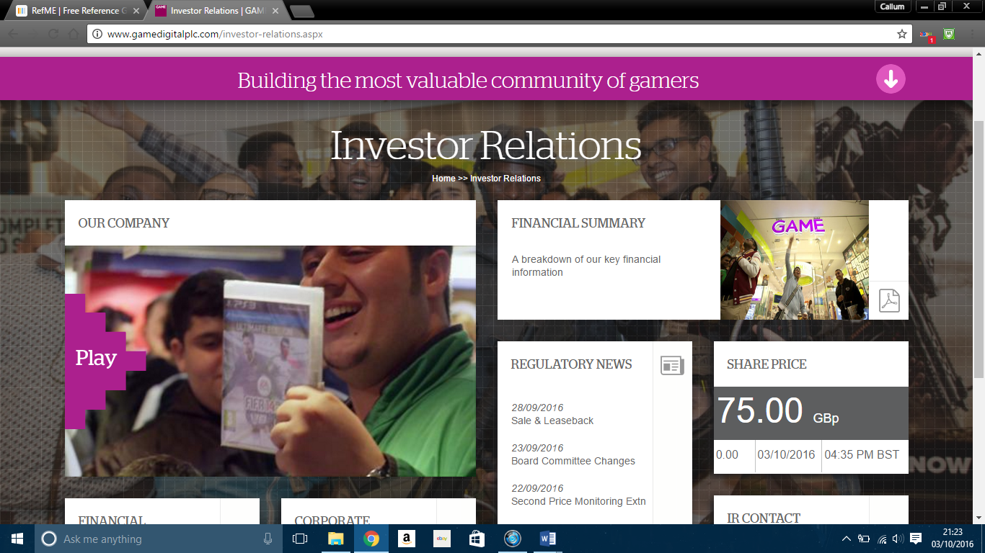The aims and objectives of GAME as a company are generally sales and profit driven. These aims can effect a shareholders’ decision to invest in the business by judging how it will benefit them. As of 03/10/16 the share price to become an investor in GAME is £75.

The aims and objectives of GAME are as follows:

1. “MAXIMISE MARKET SHARE OF CONSOLE PHYSICAL CONTENT

The Group seeks consistently to achieve a high level of market share in new console physical content by focusing efforts on driving sales of new content together with its key suppliers through marketing events, first-to-market offerings and exclusive content, all delivered by dedicated in-store and online teams.” (GAME, 2012).

This objective means that GAME strives to achieve a larger market share through sales of products earlier than other companies (or being the first on the market) meaning that customers are more likely to purchase the item from them as nowhere else would have it up for order. Also, exclusive deals can encourage customers to visit the store as they feel like they are getting more for their money. This objective would affect shareholders in a positive way as more sales means higher profits meaning that they will receive more money as a dividend, this increase in sales could encourage a shareholder to invest further in the business

1. “MAXIMISE MARKET SHARE OF CONSOLE AND NON-CONSOLE DIGITAL CONTENT

The Directors believe that a key growth driver of the video game market will be the advancement of digital content within the video gaming community and that digital content will contribute an increasing proportion of the GAME Digital’s revenue over the medium-to-long term. The growth of Microsoft Xbox Live, PlayStation Network and PC gaming websites has led to increased consumer demand for DLC, digital subscriptions and digital platform currency. The Directors believe that there is scope for significant growth of GAME Digital’s digital range.” (GAME, 2012).

As a company, GAME is beginning to look forward to the future of gaming in a digital sense. The majority of game purchases are made via the console now whether they are dlc for games or the game itself on either the consoles store or on a PC through services such as steam. GAME is now starting to offer additional services to the ones that they already cover, by selling code cards for things such as Microsoft points, Xbox live or credits for digital game stores. In turn, this is generating an additional source of income from a potentially new market of gamers that the company could not service before. This is beneficial for both the business and its stakeholders as GAME have a significantly higher revenue stream which then means that shareholders will get higher amounts of money in the dividends that they receive.

1. “PROMOTE PRE-OWNED PRODUCTS TO BOTH CAPTURE MARKET SHARE AND GROW THE ABSOLUTE MARKET

GAME Digital’s market share of pre-owned is strong, with a 39 per cent market share of the UK pre-owned physical content market in 2013**. By 2017, the Directors expect the pre-owned segment of the Group’s business to be substantially larger as a proportion of its profits after tax than it is currently due to the increased mix of pre-owned devices, which include tablets, phones and other technology. The Group’s pre-owned products typically generate substantially higher gross margins than new products as the Group has greater control over the pricing of such products” (Game, 2012)

GAME already has a successful place in the pre-ordered games market. Over the coming year, GAME wants to add in further products to their pre-owned section that they have previously not sold in stores or online before. They aim to do this because they believe that it will become another solid source of finance for the business in terms of bringing in a constant revenue stream. It will also help them to compete with competitors such as CEX which have offered this service since they opened in 1992 in London. (Butler and Mullins, 1999). For stakeholders this again means that they will be receiving more in dividends and potential shareholders may be more likely to invest.

1. “BROADEN PRODUCT AND SERVICE OFFERING AND TARGET A BROADER GAMING COMMUNITY

In keeping with our goal to be at the centre of the video gaming community in the UK and Spain, we are focused on broadening our product and service offerings to make sure we can accommodate the evolving needs of gamers in the UK and in Spain and drive value from this. In addition to the hardware and content, we offer- accessories, toys, collectibles, clothing and other gaming-related merchandise, as well as product warranty coverage” (GAME, 2012).

This objective relates hand in hand with the previous one by adding more services to the store. In adding more services and products to the store, potential customers may be drawn in by the wider range of services offered. In turn, this would bring in more customers and more money. This money could then be split between the business itself and shareholders as dividends.

# Analysis of current ecommerce system

GAME already has an established ecommerce presence. This will now be evaluated in terms of its effectiveness and security.

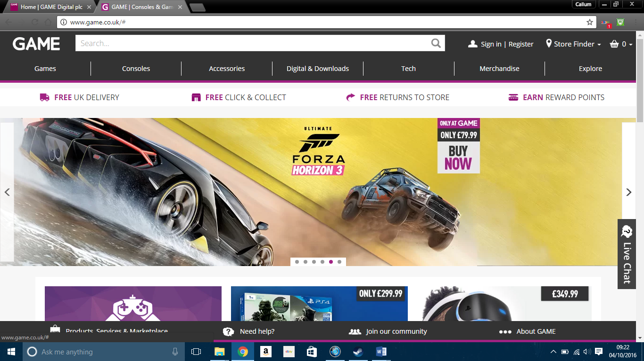

The layout of the current site is effective as there is a navigation pane at the top of the page with a search bar and links to each of the products and services that are offered. This makes navigating the site easy for customers as they are able to find what they are looking for quickly and easily without any trouble.

GAME makes use of a discount system in their store called rewards points. These give discounts on purchases made online and in stores and are earned when each purchase is delivered. The amount earned depends on the price of the item bought. This can prove to be an incentive in making customers buy more often from the store as the discount points can continue to mount up if not spent.

There are multiple ways of payment in GAMEs current ecommerce system. The customer can either pay by card or by PayPal. By using PayPal as a payment method, an additional layer of security is added to the transaction as the funds transfer has to go through both GAME’s website and PayPal. Of course though there is no such thing as 100% security as with anything. For example, there could be copy websites made by fraudsters. These sites could be exact replicas of transaction sites like PayPal and could con customers out of their details or out of money that they may not be able to get back from their bank. This could potentially stop payments from clearing because the customer may have pre-ordered a product, received the con email and paid thinking that they were paying for their pre-order. This means that when their actual pre-order needs paying for they might not have sufficient funding for it to clear and the order may be cancelled.

These sites could also allow malware to gain access to the computer system rendering it unusable for the user. This would then mean that the user would have to reset their computer, removing everything including any unsaved work that could be potentially very important for the user.

For the customers security, GAME should use a system where the customer can make a PayPal payment agreement which will allow PayPal to hold the funds until the item is released. This is done during the order stage so would require no further interaction. This would reduce the risk of customers responding to fraudulent emails as once ordered, the customer will need no further interaction unless they wish to cancel the product.

The customer must also be weary when dealing with emails as no actual payment company will ask them for their details. If the customer is asked for their personal details, then the email is likely to be fraudulent.

# http://www.triua.com/wp-content/uploads/e-commerce-advantages-and-disadvantages.jpgGlobal impact of ecommerce on society

Although ecommerce does have a positive impact on society as a whole, it is not without its drawbacks

One of the drawbacks of ecommerce is that goods are not received upon payment like they would be in store. Instead, the customer would have to wait for their item to arrive in the post. “An exception to this rule is in the case of digital goods, e.g. an ebook or a music file. In this case, e-commerce might actually be faster than purchasing goods from a physical store” (Khurana, 2016a). This is only an exception to the rule as digital transactions occur instantaneously within very minimal delay.

The main problem in relation “Anyone Can Set Up an e-Commerce Website. We live in an era where online storefront providers bring you the ability to set up an e-commerce store within minutes. I have tried it, and it is possible to set up a basic store in under 10 minutes. But if anybody can set up a store, how do I know that the store I am purchasing from is genuine? The lowered barriers to entry might be a great attraction to the aspiring e-commerce entrepreneur. But for the buyer, reliability can be an issue. This could lead customers to restrict their online purchases to famous e-commerce websites.” (Khurana, 2016a).

This relates to fraudulent or fake websites. These websites can be promising products but not deliver, although they could also be clone websites that can allow hackers access to your computer. This means that once you enter your details, they are no longer yours. The hacker has access to all of your accounts linked to that information including bank details that can allow hackers to steal your money either discreetly overtime or in one fell swoop. this type of crime has become a lot more common place over the years as more and more people are starting to bank online. Also, hackers are able to steal a lot more money online than they would be able to if they physically robbed a bank of its contents. Lack of security on a website could lead fraud or even identity theft.

However, the positives outweigh the negatives for ecommerce. For example, customers are not limited to a location. This is because most ecommerce businesses ship internationally across the globe. This means that there are no limitations to what customers can buy so long as they are willing to pay import fees. GAME currently offers international shipping both within and out of the eu which is beneficial due to the UK’s recent decision to leave the eu. As GAME already ships outside the eu this part of the business will not be effected.

In relation to the global market, ecommerce stores need to remain open 24/7, 365 unlike physical stores which have a set closing time. This is so that all potential customers are able to buy their products at any time, no matter what country they are in. Because of this, staff at the store would have to work flexible hours, i.e. they do not have set shifts, so that they are able to package and ship any items ordered. GAME’s ecommerce staff would have to do this as they may have to ship an item abroad and will have process the payment, confirm the transaction and inform the customer. Although this is very convenient for the business as more revenue is being made, “from the customer's point of view, an always open store is more convenient”. (Khurana, 2016b)

A way a business can see the effect that it is having on society is through the use of undertaking a PEST analysis. “A PEST analysis is a business measurement tool. PEST is an acronym for Political, Economic, Social and Technological factors, which are used to assess the market for a business or organizational unit” (Chapman, 2016). Each of these factors will now be assessed for GAME to see how they meet the needs of society.

Political – Recent reports in the media, such as the BBC have shown video games to be suggestive and violent.

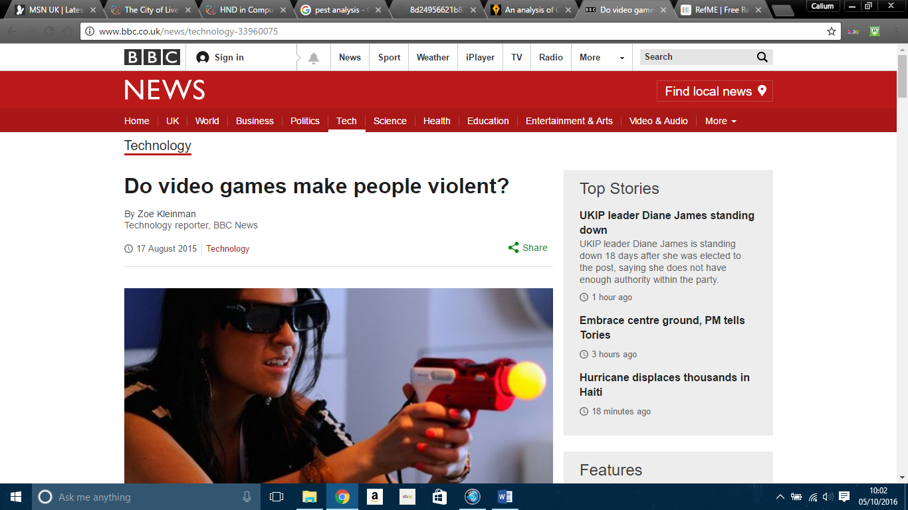The majority of these reports feature popular games such as Grand Theft Auto and Call of Duty. These reports showing video games in a bad light have caused parents to want a ban placed on video games of such content. If these were banned, then GAME would lose a lot of money as these are some of the most popular games on the market that wouldn’t be able to be bought, resulting in a loss for the business. Many news stations have picked up on this topic in greater detail, an example article can be found at the BBC discussing both sides of the argument on video games.

(Kleinman, 2015)

Economic – Right now after the recent decision to leave the eu, the pound is starting to plummet and is continuing to do so. This could prove to be impactful for GAME as due to Brexit, there may soon be limitations on the import and export of products and import fees will be applicable to all countries if no agreement is made in regards to trading when article 50 is triggered. This would be impactful for GAME as oversees customers would be less likely to buy from them due to increased prices.

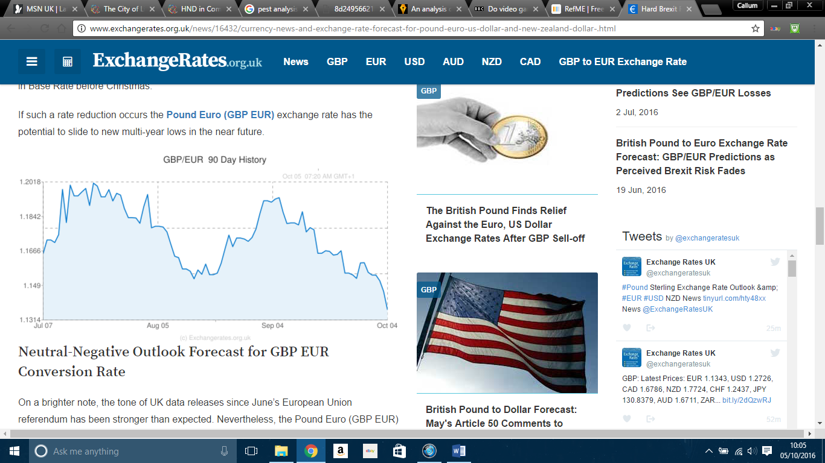

(Cameron, 2016)

Social – Due to media representation of video games, customers buying habits could possibly change as a result. For example, if young children play video games and have their parents buy the games for them, the parents may see these articles and news reports and become weary of what they are buying their children and eventually stop buying these products. This would have a negative impact on GAME as the media would be deterring away potential business and although GAME would still have customers in the form of teens and adults, their revenue would not as high as it once was.

Technological – Because of the constant advancements in technology, GAME has to keep up to date with it all in order to remain on top of the market. Over recent years, video games have started to go digital. GAME offers digital versions of games on their site. Once purchased, the download code is sent to the customer via email allowing them to download their purchase. As of august, sales have begun to rise once more due to recent pre-orders going up for the new Xbox one s and PS4. This is beneficial for GAME as this means more money and more sales.

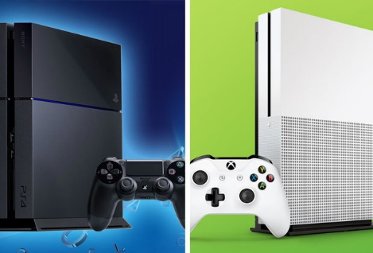

# Conclusion

Overall, GAME is a structurally sound company with a fully established ecommerce presence. The objectives and aims that they strive to achieve are do-able and there is a possibility that can be achieved in the long run. Their webpage has a suitable layout that makes it easy for users to navigate and find what they are looking for with ease, thanks to the layout being tailored to the screen making the most use out of the space available. It is good that the company uses payment methods such as PayPal as these are generally more secure than just making a purchase through the site itself. Although PayPal is not without its problems, it is more secure than general purchases. The products and services that GAME offers have recently been portrayed in a bad light by the press and the media, making parents of children hesitant to buy them. Along with this, due to Brexit, international trade will be low due to the fact that imports will soon be in play. This would deter international customers from buying products as they would be paying more than they would be if they bought locally.

In order to combat these issues, GAME would have to make a contingency plan in order to overcome these inevitable issues.

# Bibliography

Butler, D. and Mullins, D. (1999) *CeX (UK): About CeX*. Available at: <https://uk.webuy.com/about/history.php> (Accessed: 3 October 2016).

Cameron, J. (2016) Hard Brexit reaction: British pound to Euro, Australian, New Zealand + US dollar exchange rates holding record lows. Available at: <http://www.exchangerates.org.uk/news/16432/currency-news-and-exchange-rate-forecast-for-pound-euro-us-dollar-and-new-zealand-dollar-.html> (Accessed: 5 October 2016).

Chapman, A. (2016) Free PEST market analysis template and method, free pest market analysis examples. Available at: <http://www.businessballs.com/pestanalysisfreetemplate.htm> (Accessed: 4 October 2016).

GAME (2012) About GAME. Available at: <http://www.gamedigitalplc.com/about-game.aspx> (Accessed: 28 September 2016).

Khurana, A. (2016a) When Ecommerce Isn’t so great. Available at: <https://www.thebalance.com/disadvantages-of-e-commerce-1141571> (Accessed: 4 October 2016).

Khurana, A. (2016b) 11 reasons Ecommerce is taking the retail world by storm. Available at: <https://www.thebalance.com/advantages-of-ecommerce-1141610> (Accessed: 4 October 2016).

Kleinman, Z. (2015) Do video games make people violent? Available at: <http://www.bbc.co.uk/news/technology-33960075> (Accessed: 5 October 2016).

# Appendices

GAME board of directors found at <http://www.gamedigitalplc.com/about-game/our-board.aspx> (Accessed on 5 October 2016.)

